***Estimation of Business Expenses***

**1.Introduction**

This report delves into the fascinating realm of business expenses and provides a visual exploration of the various expenditures incurred by different businesses. It showcases the distribution of expenses, identifies key cost drivers, and highlights areas of potential optimization or concern. The visual representations allow for intuitive analysis, facilitating a deeper understanding of expenditure patterns and their implications for business performance. Decision-makers, financial analysts, and stakeholders can gain valuable insights into the financial health of businesses, identify areas of inefficiency or opportunity, and make informed decisions to optimize resources and drive growth. To Extract the Insights from the data and put the data in the form of visualizations, Dashboards and Story we employed Tableau tool.

This involves estimation all the expenses required to start and operate the the business, such as equipment, rent, inventory, and marketing. By calculating these costs upfront, business owners can better plan their budget and avoid unexpected expenses.

**Technical Architecture**

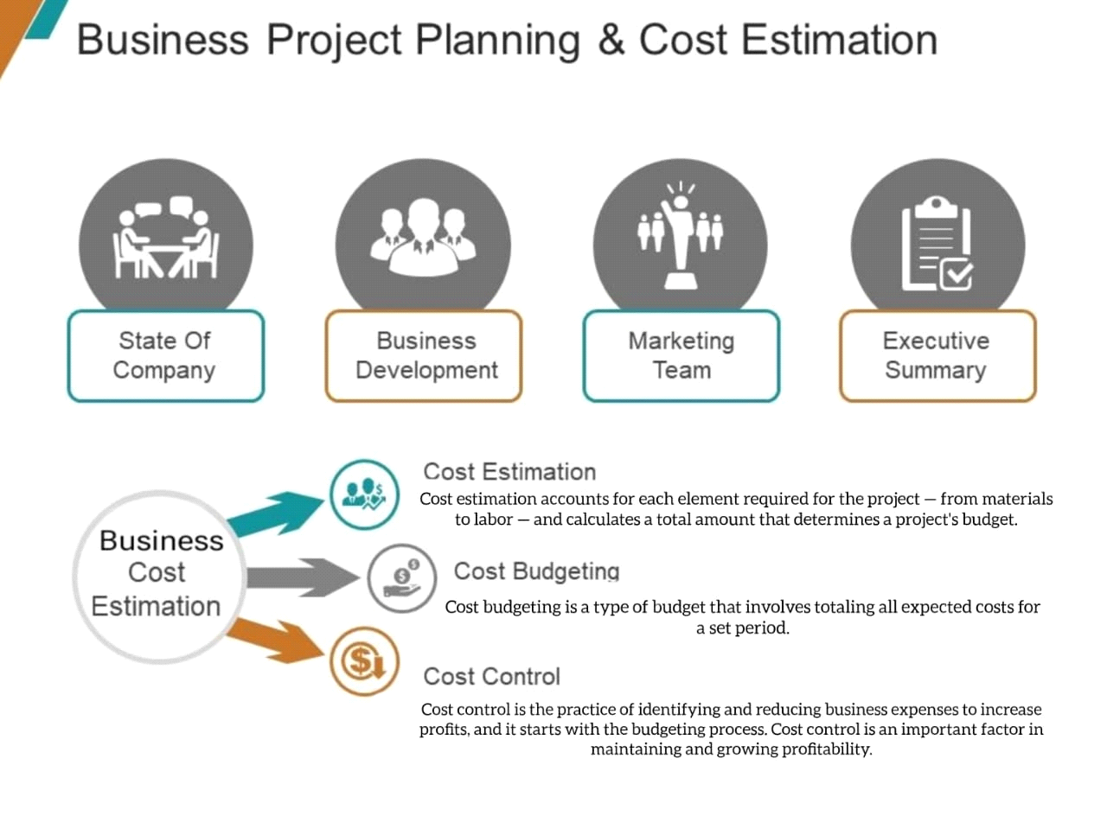 **2.Problem Defination & Design Thinking:**

**2.1 EMPATHY MAP**

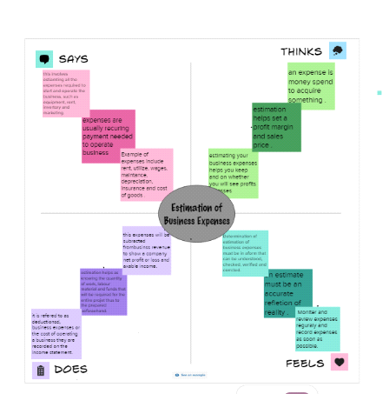

**2.2 IDEATION & BRINSTORMING MAP:**

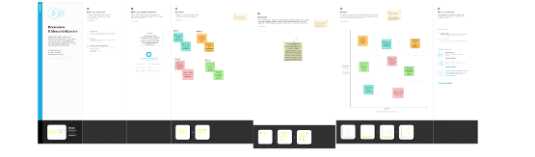

**3. Result:**

**For Empathy Map:**

**#** An empathy map helps describe the aspects of a users experience,needs and pain points.

**#** This template allows you to quickly undestand your users experience and mindset.

**For Brainstorming:**

**#** Brainstorming provides a free and oen environment that encourge everyone within a team to participate in the creative thinking process that leads to problem solving.

**#** Priotizing volume over value, out-of-the-box ideas are welcome and built upon, and all participants are encouraged to collaborate, helping each other develop a rich amount of creative solutions.

**4. Advantages:**

**For Empathy Map:**

**#** More understanding of the Target Audience.

**#** More Organized Informtion in easy to understand format.

**#** Fast, Inexpensive and easy customiztion.

**#** Common understanding and same mindset of whole team members.

**#** Empathy improves our capacity to communiate well with others, not just individually but asd part of team.

**#** It will helps you to effectively lead and linspire others, and develop more compassionate relationships, anticipate the needs of clients.

**For Brainstroming:**

**#** The benefits of brainstorming are numerous. Brainstorming builds involvment, commitment, loyalty, and enthusiasm. Participating in the sessions stimulates and unlocks peoples creative talents.

**#** Brainstorming helps writers generate more ideas before beginning to write about a topic.

**#** It can also help reduce writing anxiety and focus attention on the most relevant content when writing.

**#** Brainstorming is an essential step step before outlining the msjor points needed to create a well-organized essay.



**5.** **Disadvantages:**

**For Empathy Map:**

**#** They are designed to capture the needs and perspectives of a specific audience, but may not capture the needs and perspectives of other stakeholders. For example an em[athy map creted for custorms may not capture the needs and perspectives jof employee or suppliers.

**#** The pains section is where you want to find out what are their fears, frustrations, and the obstacles they needs to overcome.

**For Brainstorming:**

**#** can take too much time if the group is not properly controlled and is allowed tp run fpr tpp long.

**#** Raising expectations of the brainstormig group by considering ideas that will never be implemented.

**#** The disadvantages of free form brainstorming is tyhat the less assertive or low-ranking participants may not contribute.

**#** Which is a method for developing new concepts to solve problems by looking at then in innovative ways.

**6. Applications:**

Cost estimation helps you determine your projects budget, schedule the work necessary and mange new resources. cost estimation are also very crucial when it comes to winning newbusiness. property owners also use cost estimates to assess the feasibility of their projects before embarking on actual construction.

Your income statement is the main financial statement used when recording business epenses and determining your taxable income. The income state;ment shows a picture of your companys expenses and revenues over a given period of times.

**7. Conclusion:**

In cost estimation is an important component of project management that ensures project are finished on scheduled and within budget. Since inaccurate cost estimates cvan have serious financial consequences for business, accurate costs estimating is crucial for all stakeholders engaged in a project.

**Sheet 1**

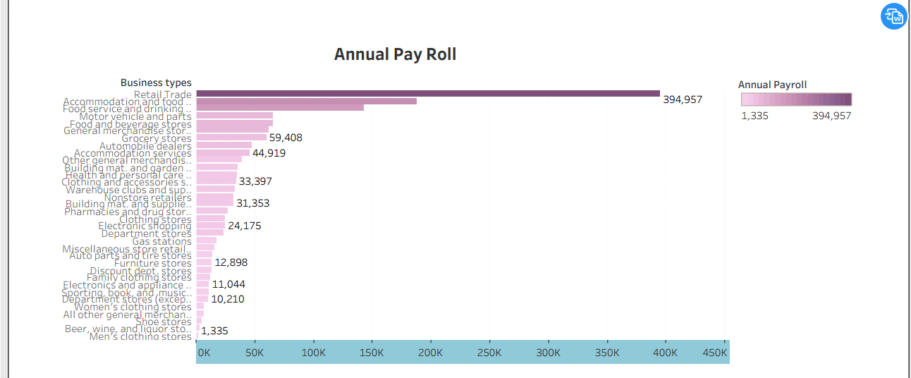

**Sheet 2**

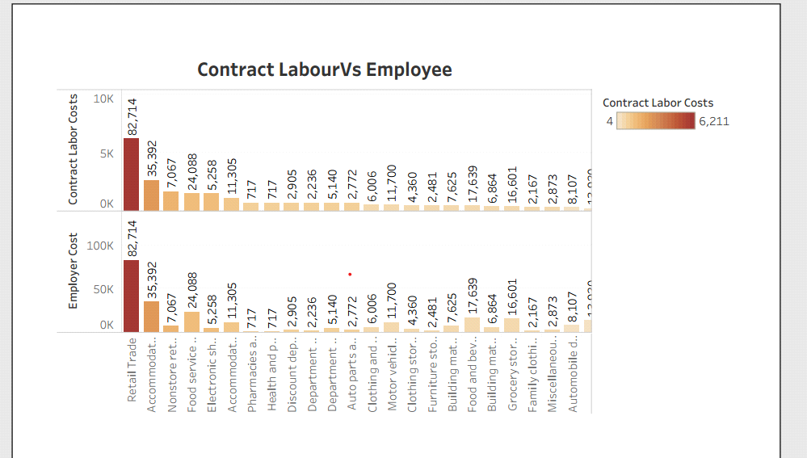

**sheet 3**

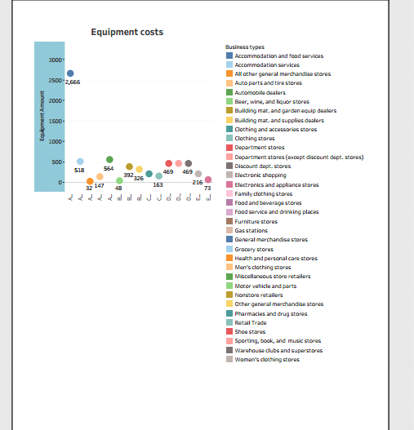**Sheet 4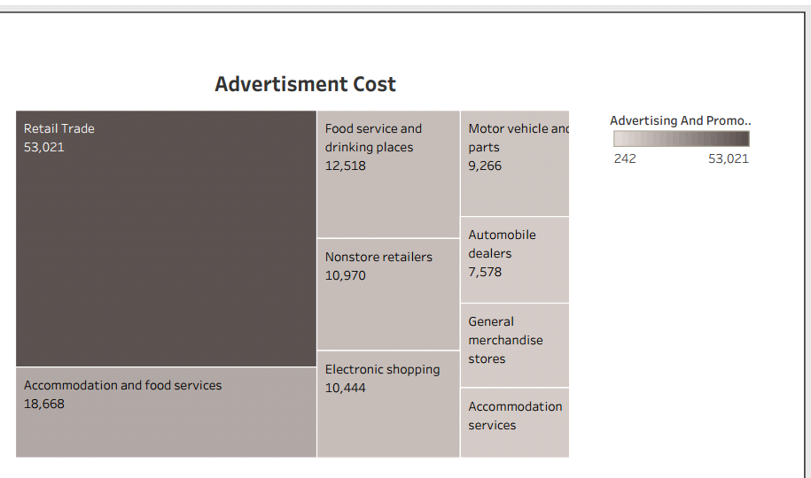Dashboard**

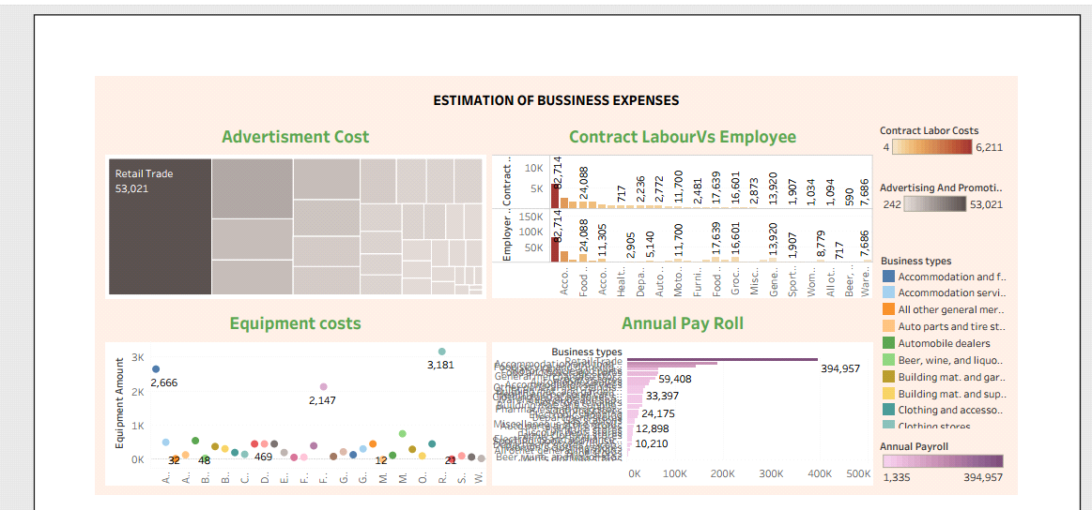**Story 1**

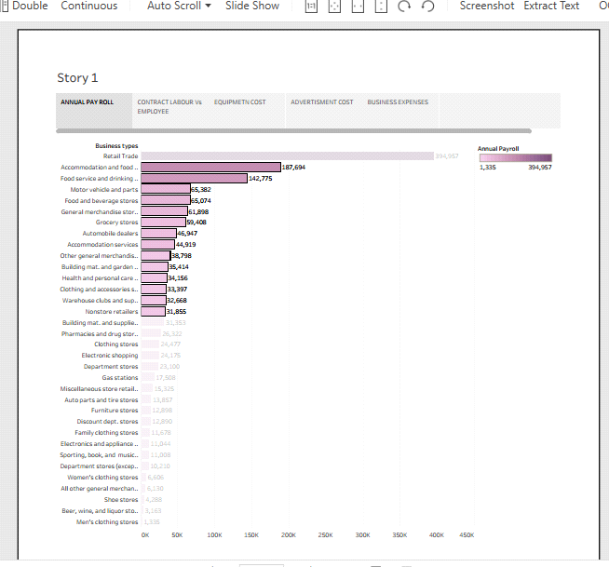

**Story 2**

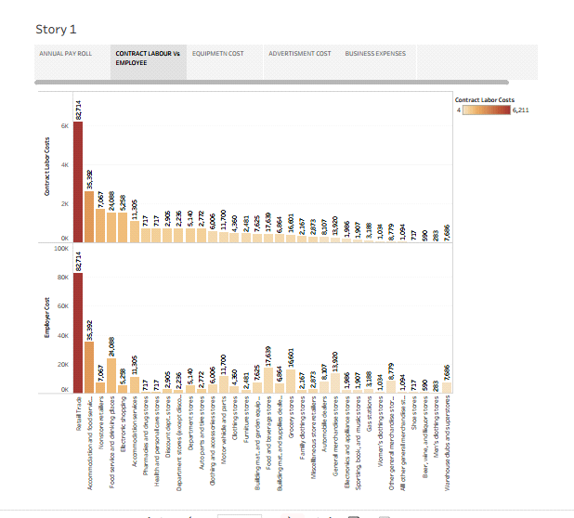

**Story 3**

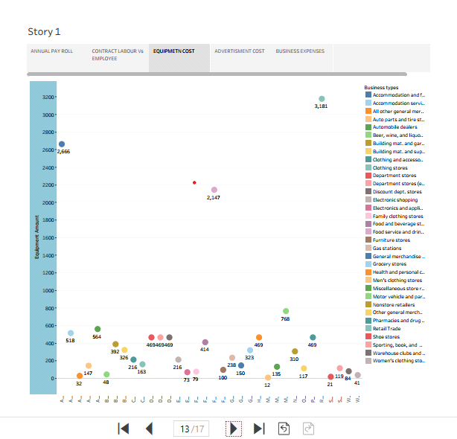

**Story 4**

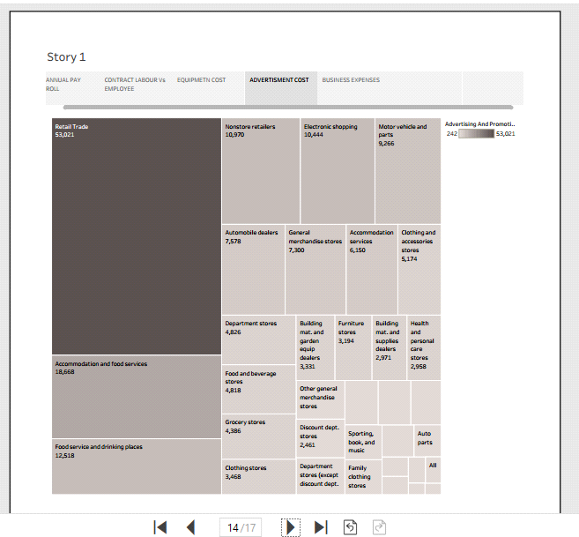

**7. Future Scope:**

They can work on more complex projects and provide accurates estimates for their clients. Estimation engineers will also be abe to use new software to help them with their work. Thus software will allow them to create more accurate estimates and save time on their projects.